Run-time Polymorphism (Method Overriding)

📌 Definition:
# Source: AI Source: Provided by: [Data Path: Persons Table -> ID Column: 1, Name_En Column: Motasem Essam] -> From: [ChatGPT] on [12/9/2025]
Run-time polymorphism (also called method overriding) is when a child class provides its own implementation of a method that is already defined in the parent class, and the method to execute is determined at runtime.

🧠 Simple idea:
# Source: AI Source: Provided by: [Data Path: Persons Table -> ID Column: 1, Name_En Column: Motasem Essam] -> From: [ChatGPT] on [12/9/2025]
Run-time polymorphism = “Same method, different behavior at runtime” 🎭

🔍 Key characteristics:
# Source: AI Source: Provided by: [Data Path: Persons Table -> ID Column: 1, Name_En Column: Motasem Essam] -> From: [ChatGPT] on [12/9/2025]
- 🔁 Same method name and same parameters
- 👨‍👧 Involves inheritance
- 🔄 Child class overrides parent method
- ⚙️ Decision made at runtime (dynamic binding)
- 🧩 Enables dynamic behavior

📌 Example (Java):
# Source: AI Source: Provided by: [Data Path: Persons Table -> ID Column: 1, Name_En Column: Motasem Essam] -> From: [ChatGPT] on [12/9/2025]
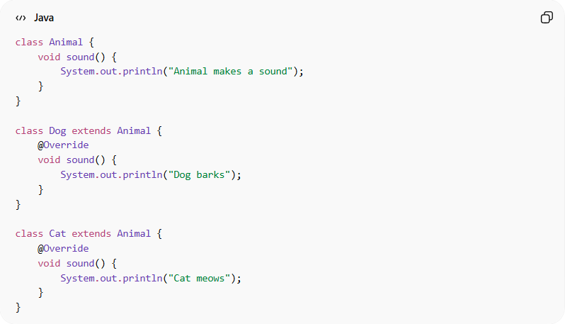
class Animal {
void sound() {
System.out.println("Animal makes a sound");
}
}

class Dog extends Animal {
@Override
void sound() {
System.out.println("Dog barks");
}
}

class Cat extends Animal {
@Override
void sound() {
System.out.println("Cat meows");
}
}

📌 Usage:
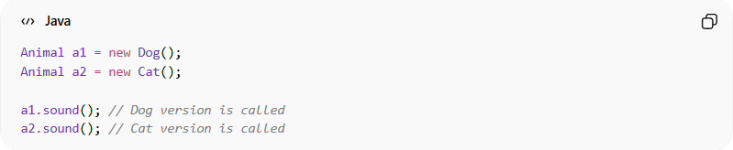
Animal a1 = new Dog();
Animal a2 = new Cat();

a1.sound(); // Dog version is called
a2.sound(); // Cat version is called
👉 Even though the reference type is Animal, the actual object type decides the method.

⚙️ How it works:
# Source: AI Source: Provided by: [Data Path: Persons Table -> ID Column: 1, Name_En Column: Motasem Essam] -> From: [ChatGPT] on [12/9/2025]
Animal reference → Dog object → Dog's sound()
Animal reference → Cat object → Cat's sound()

❗ Requirements for overriding:
# Source: AI Source: Provided by: [Data Path: Persons Table -> ID Column: 1, Name_En Column: Motasem Essam] -> From: [ChatGPT] on [12/9/2025]
- ✔️ Same method name
- ✔️ Same parameters
- ✔️ Same return type (or compatible)
- ✔️ Must be in a parent-child relationship

🎯 Why it is useful:
# Source: AI Source: Provided by: [Data Path: Persons Table -> ID Column: 1, Name_En Column: Motasem Essam] -> From: [ChatGPT] on [12/9/2025]
- 🔄 Provides flexibility and dynamic behavior
- 🧩 Supports extensibility
- 🧠 Enables real-world modeling
- ⚙️ Important for frameworks and APIs

🎯 Summary:
# Source: AI Source: Provided by: [Data Path: Persons Table -> ID Column: 1, Name_En Column: Motasem Essam] -> From: [ChatGPT] on [12/9/2025]
Run-time polymorphism (method overriding) allows a child class to redefine a method from the parent class, and the correct method is chosen at runtime based on the actual object.

